LEAGUE CITY GYPSY M/C 19th Annual FALLDOWN Motorcycle Rally Sept. 31st, Oct 1st and 2nd 2016 Galveston County Fairgrounds ~ Santa Fe, Texas
Tent & RV Camping Meal on Saturday Live Auction
Real flushing toilets Fun Run Burn Out Competition!
Usual Beverages The Infamous Ice Block!
Bike, People, & Kid Games LIVE BANDS!!

Gate registration begins @ 5pm Friday at Galveston County Fairgrounds. On Hwy 6 between FM 646 and FM 2004-Between Santa Fe & Hitchcock
RV’s Welcome---(SELF CONTAINED)---Vendors Welcome---vendor fee $30
For more information call: Can Evil (361) 446-2345 or Bullmoose (832) 738-2444
Or check https://www.facebook.com/groups/LCGYPSYMC/
Mail Pre-Registration to:
League City Gypsy M/C-PO Box 757- League City, TX 77574
Pre-Registration $18.00 – Gate Registration $20.00 – Kids 12 and under Free
Pre-Registration Closes September 15, 2015 ***no pets—no weapons—no attitudes***
Name(s): ______________________________ Club: __________________________
Address: ______________________________ City: _____________ State: ____ Zip: _______

Total Enclosed: $__________Name: ____________________ Passenger: ______________________For more information about Gypsy MC to http://www.gypsy-mc.org

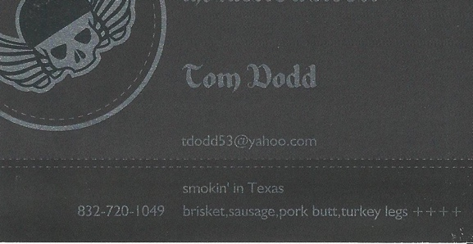
Food by D-Tox and the Meat Wagon

