LA FERIA GYPSY M/C  24TH ANNUAL  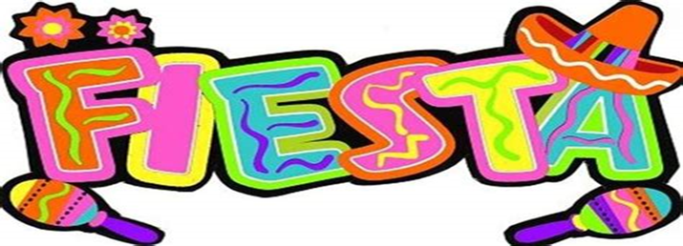  R U N 2019  MARCH 8TH THRU 10TH 2019  MAD BOAR  HARLEY -DAVIDSON  3515 WEST EXP. WAY 83 (US 77)  SAN BENITO, TX. 78586  CHECKS PAYABLE TO: LA FERIA GYPSY M/C  MAIL TO: LA FERIA GYPSY M/C  409 E. MONROE ST. HARLINGEN, TX. 78550  For any further Information please contact Carmen Goss ‘TWIST-Я’ (956)-499-6616 or email only1_cinnamongirl@yahoo.com  RIDER______________________________________________________________  PASSANGERS/KIDS___________________________________________________  CLUB/ CHAPTER MEMBERS____________________________________________  ____________________________________________________________________  ADDRESS____________________________________________________________  PHONE#_____________________________________________________________  I/WE AGREE NOT TO HOLD LA FERIA GYPSY MC, MAD BOAR HARLEY- DAVIDSON, CITY OF SAN BENITO  OR ANY OTHER PERSONS OR SPONSERS LIABLE FOR ANY ACCIDENT, INJURY, OR DAMAGE TO ANY  PERSONAL PROPERTY DURING OR AFTER THE 2018 FIESTA RUN EVENT.  SIGNATURE(S)______________________________________________________________________  GYPSY MC INTERNATION WEBSITE: www.gypsy-mc.org | PROCEEDS FROM THIS EVENT  GO TO ALZEIMER’S  ASSOCIATION  CAMERON COUNTY DIVISION  GATE OPENS @ NOON ON FRIDAY  COME JOIN THE FUN  USUAL GYPSY REFRESHMENTS  KARAOKE FRIDAY NIGHT  WITH GOLDELOXXX  LIVE MUSIC SATURDAY NIGHT WITH  SOUTHGATE BAND  PRE-REGISTRATION BEFORE FEB 28TH  ADULTS $ 18.00  KIDS 6 – 12 $ 5.00  AT THE GATE  ADULTS $ 25.00  KIDS 6 -12 $ 10.00  SELF CONTAINED RVs  ----  Limited Run Patches  -----  Entertainment  -----  FRIDAY & SATURDAY MEAL  -----  50/50 & Live –Auction  Vendors welcome Vendor fee $20 plus Auction Item  

