Big D Labor Day Bash & Lifer Appreciation Party 2023
September 1-4, 2023
$25.00 Per Person or $40.00 per Couple
Free Admission for all Lifers & Kids
For Information Contact: Shaggy @ 903-413-8642

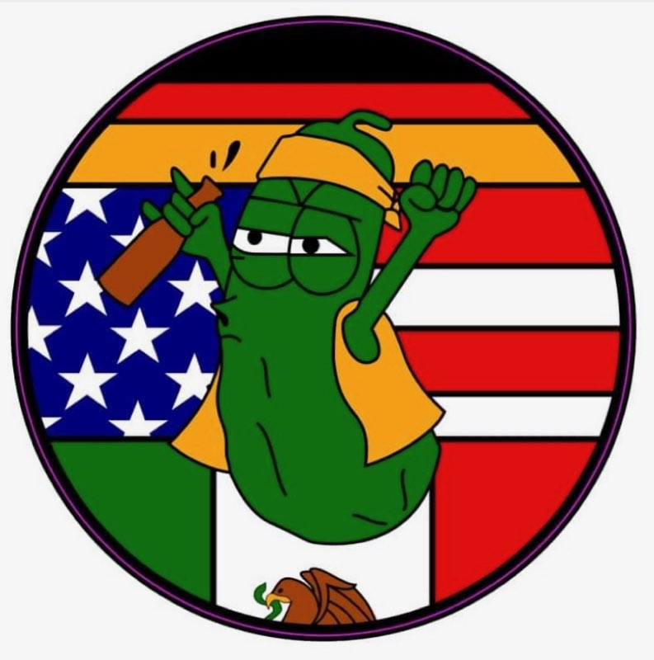
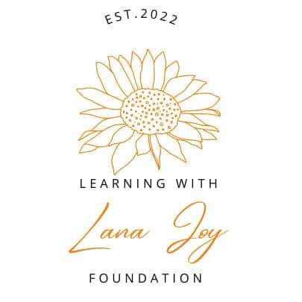
MUSIC FRIDAY & SATURDAY

BIKE, STUPID PEOPLE AND KIDS GAMES SATURDAY
PLACE: 11293 SW County Rd 3010
Purdon, TX 76679

GATE OPENS AT NOON FRIDAY
PRIMITIVE CAMPING ONLY

SEVERAL VENDORS & USUAL REFRESHMENTS

