

TOYS FOR TOTS
HOSTED BY THE DEL RIO CHAPTER, GYPSY M/C
NOVEMBER 14, 2015
The Buzzard’s Roost @ 4411 Veteran’s Blvd
2 PM TILL CLOSING

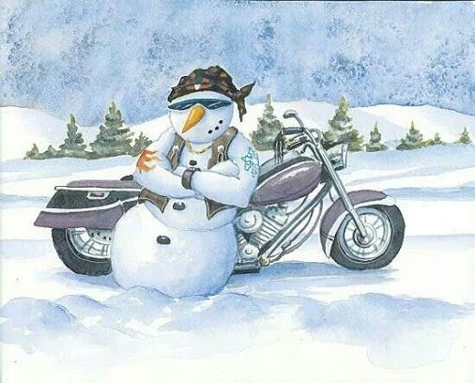
$10.00 OR NEW TOY
AUCTION/DOOR PRIZE’S/MUSIC
PLEASE COME AND
HELP A CHILD HAVE A
BLESSED CHRISTMAS HOLIDAY
THANK YOU FOR YOUR SUPPORT

Points of contact: Carl “No Show” Green
830-734-3184
Diana “Hi Beam” Jameson

830-734-9066

